|  |  |
| --- | --- |
| j0236335 | Eastern Goldfields College  Year 12 Investigation Mathematics Methods  Area Under A Curve – Take Home |

**Problems**

a) How far will a car travel at a speed of 50 km/hr for 3.5 hours?

b) The velocity/time graph below represents such a journey.

Velocity

(km/hr)

1

2

3

4

50

40

30

20

10

Time (hours)

i) What is the area of each ‘rectangle’ in the grid and what does it represent?

ii) What is the area of the shaded region?

Below is the graph of another journey

10

20

30

40

50

40

30

20

10

Time **(seconds)**

Velocity

(km/hr)

a) What is the area of each square in the grid and what does it represent?

b) What is the area of the shaded region?

c) What is the significance of your answer above to the journey?

**Area Under a Curve**

1. For the given interval, determine the area between the graph of the given function and the **x**-axis:

a. Interval: 1≤ **x** ≤ 3 b. Interval: 2 ≤ **x** ≤ 4

Function: **y**  **x** 1 Function: **y**  **x** 1

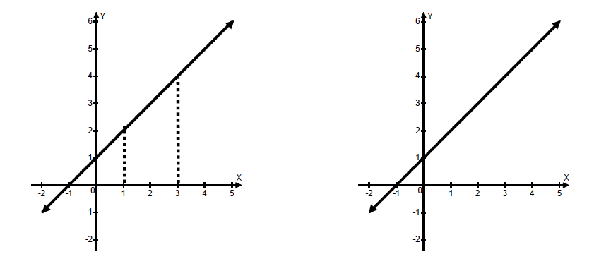

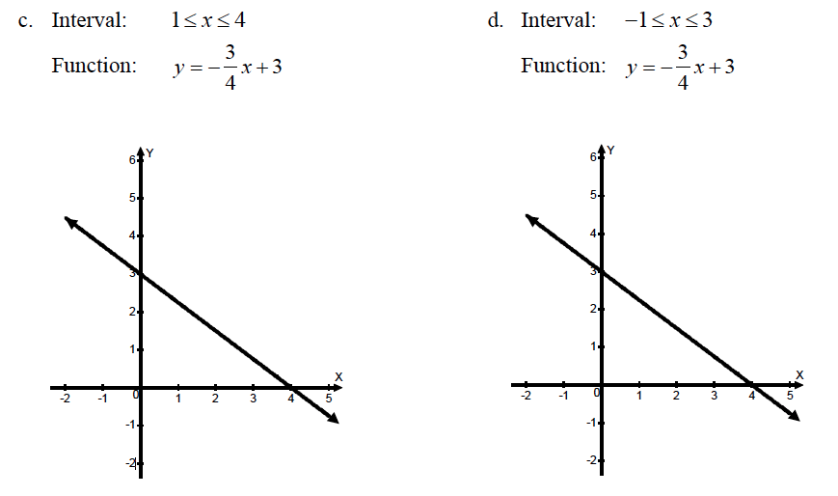

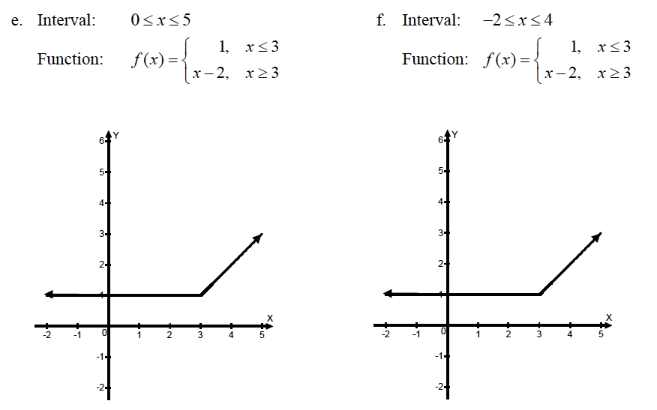

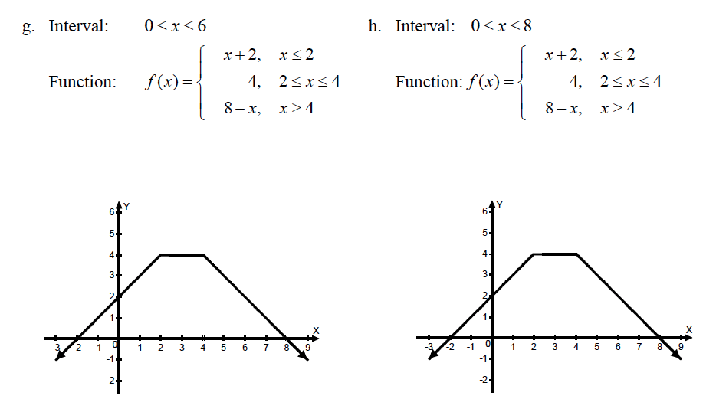

2. Approximate the area between the function and the **x**-axis for the interval shown on the graph and in the table:

i. by calculating the sum of left-hand rectangles with widths determined by the data in the table.

ii. by calculating the sum of right-hand rectangles with widths determined by the data in the table.

iii. by averaging the sums of the left-hand and right-hand rectangles and explaining why this may be a better approximation for the actual area under the curve.

a. 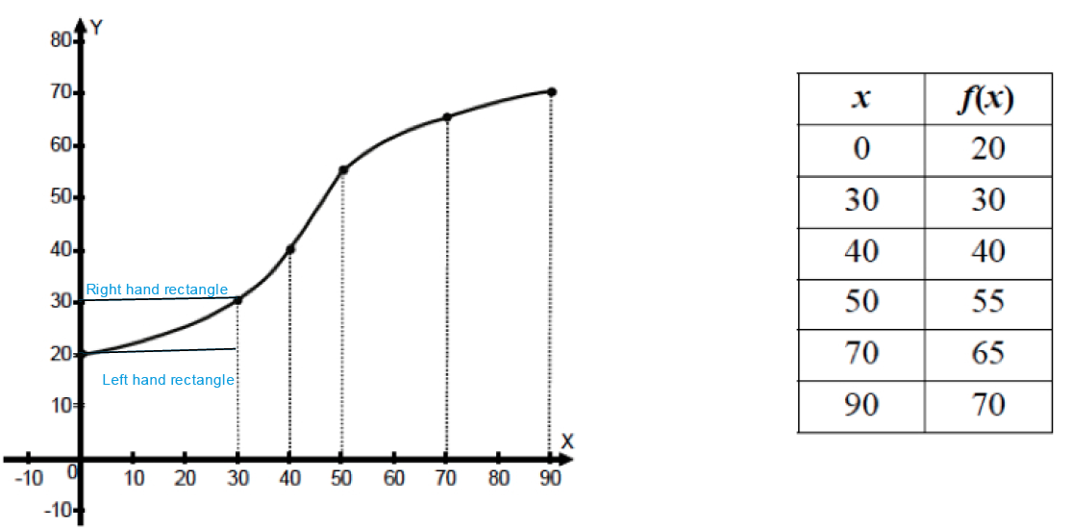

b.

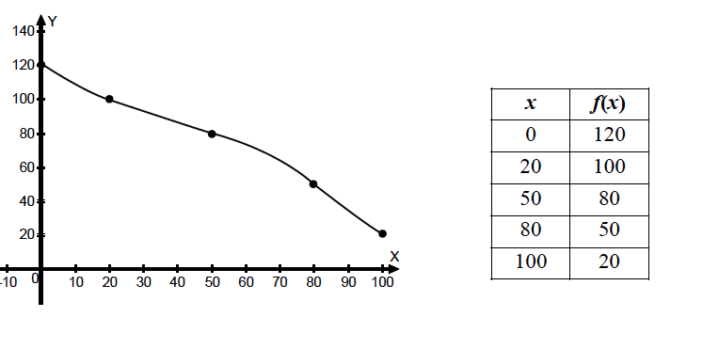

c) 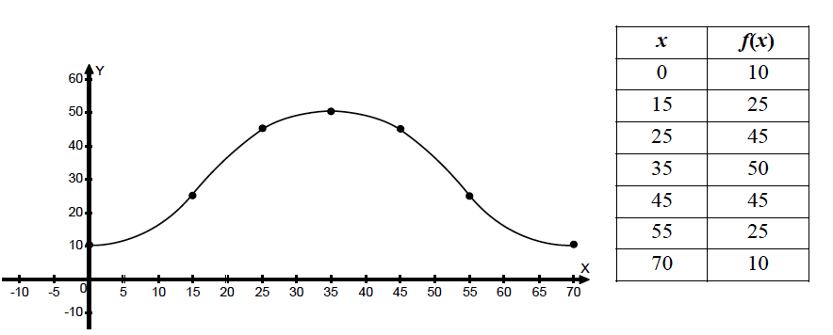

3. a) Use a graphing calculator to sketch the graph of the function y  x2  5 on the interval 0 ≤ x ≤ 5 .

b) Complete the table of values for the function.

|  |  |
| --- | --- |
| x | f(x) |
| 0 |  |
| 2 |  |
| 4 |  |
| 5 |  |

c) Use the data in the table to approximate the area under the graph of the function by calculating the sum of left-hand rectangles with widths indicated by the data table.

d) Use the data in the table to approximate the area under the graph of the function by calculating the sum of the right-hand rectangles with widths indicated by the data table.

e) Calculate the average of your answers to parts (c) and (d).